Analytical Ultracentrifuge
ProteomeLab XL-A/XL-I
Beckman Coulter

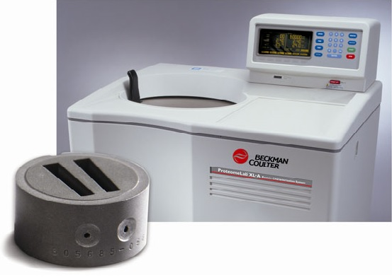
Analytical ultracentrifugation is a versatile and powerful technique for in-solution characterizing of macromolecules such as proteins, oligomers, aggregates, particles, colloids, etc. without the requirement for sample modification or the association with solid support media. This unique column-free separating technique measures the relative change in the distribution of molecular weights, providing an efficient way to measure heterogeneity, stoichiometry and self-associating systems. And, because the measurements are based on the first principles of thermodynamics and hydrodynamics, no standards or calibrations are required. Coupled with contemporary data analysis methods, AUC rigorously determines sample purity, characterizes assembly and disassembly mechanisms of biomolecular complexes, determines subunit stoichiometry, detects and characterizes macromolecular conformational changes, and measures equilibrium constants and thermodynamic parameters for self- and hetero-associating systems.

Features:
The AUC facility is equipped with a temperature controlled Beckman XL-A/XL-I analytical ultracentrifuge, fitted with absorbance and interference optics.
Multiple Detection Systems
The ProteomeLab XL-A/XL-I is configured with a scanning UV/Vis detection system that provides sensitivity for low-concentration work and selectivity for optimizing detection based on the sample's maximum absorbance. The addition of Rayleigh Interference Optics provides the capability to measure the change in refractive index resulting from changes in sample concentration. This delivers increased accuracy and the ability to examine a greater concentration range with a wider selection of samples. The XL-I can collect data from both detection systems sequentially, to provide the broadest spectrum of data for protein characterization in solution.
An-50 Ti Rotor, Analytical, 8-Place

Specifications

UNSPSC: | 41103909
Rotor Type: | Specialty
Maximum Speed: | 50,000 rpm
Maximum RCF at r max (g): | 201,600 x g
Rotor Material: | Titanium
r max: | 7.3 cm
r min: | 5.8 cm

ACCESSORIES

- An-50 Ti Rotor, Analytical, 8-Place

- Cell Assembly Individual, Quartz Windows, with Flow-Through Centerpiece

- Counterbalance, 1.3 cm

- Stand Assembly, Torque wrench

